

Network Documentation – Failover and High Availability Network Design

Project overview

his network project implements a redundant and segmented topology using HSRP (Hot Standby Router Protocol), OSPF for routing, and VLANs for logical segmentation. The network includes one Main Router and four branch routers (R1–R4), each handling different VLANs and HSRP groups for gateway redundancy.

Topology Summary

-Core Device: Main Router (connected to all branch routers via serial WAN links)

-Branch Routers: R1, R2, R3, R4

-Switches: S1 to S4 (connected to VLANs 10, 20, 30, and 40 respectively)

-End Devices: 12 PCs and 1 server

-Routing Protocol: OSPF

-Redundancy Protocol: HSRP

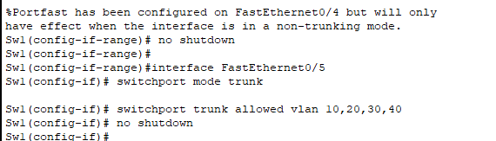

Figure 1: Full network topology including routers, switches, and end devices

IP Addressing Scheme

WAN Links- Serial Interfaces

| **Device** | **Interface** | **IP Address** | **Subnet Mask** | **Network** |
| --- | --- | --- | --- | --- |
| Main Router | S0/0/0 | 10.0.1.1 | 255.255.255.252 | 10.0.1.0/30 |
| Main Router | S0/0/1 | 10.0.2.1 | 255.255.255.252 | 10.0.2.0/30 |
| Main Router | S0/1/0 | 10.0.3.1 | 255.255.255.252 | 10.0.3.0/30 |
| Main Router | S0/1/1 | 10.0.4.1 | 255.255.255.252 | 10.0.4.0/30 |
| R1 | S0/0/0 | 10.0.1.2 | 255.255.255.252 | 10.0.1.0/30 |
| R2 | S0/0/0 | 10.0.2.2 | 255.255.255.252 | 10.0.2.0/30 |
| R3 | S0/0/0 | 10.0.3.2 | 255.255.255.252 | 10.0.3.0/30 |
| R4 | S0/0/0 | 10.0.4.2 | 255.255.255.252 | 10.0.4.0/30 |

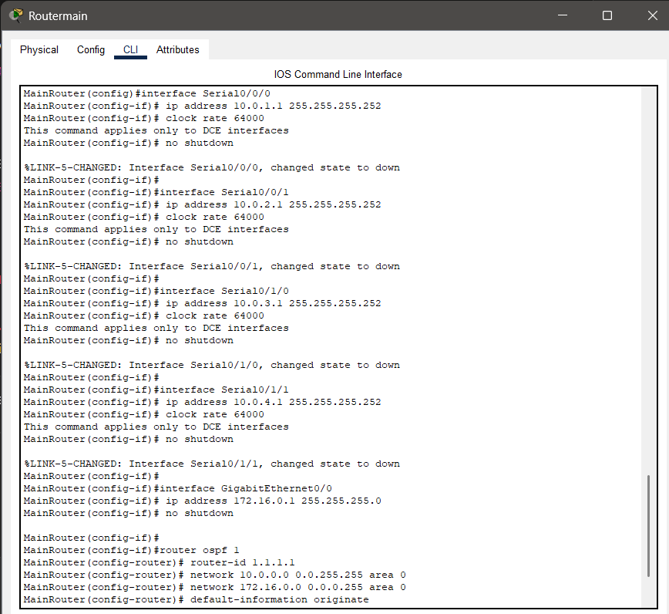

Figure 2: Serial connections from Main Router to branch routers

LAN Interfaces (Router Subinterfaces)

| **Device** | **Interface** | **IP Address** | **Subnet Mask** | **VLAN** | **Network** |
| --- | --- | --- | --- | --- | --- |
| Main | G0/0 | 172.16.0.1 | 255.255.255.0 | - | 172.16.0.0/24 |
| R1 | G0/0.10–40 | 192.168.1.1–4.1 | 255.255.255.0 | 10–40 | 192.168.x.0/24 |
| R2 | G0/0.10–40 | 192.168.1.2–4.2 | 255.255.255.0 | 10–40 | 192.168.x.0/24 |
| R3 | G0/0.10–40 | 192.168.1.3–4.3 | 255.255.255.0 | 10–40 | 192.168.x.0/24 |
| R4 | G0/0.10–40 | 192.168.1.4–4.4 | 255.255.255.0 | 10–40 | 192.168.x.0/24 |

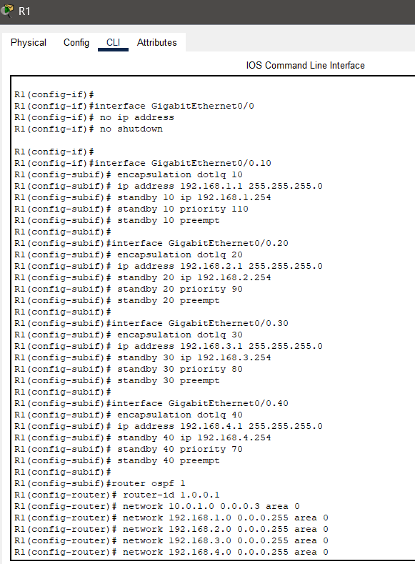

Figure 3: Subinterface setup on Router R1

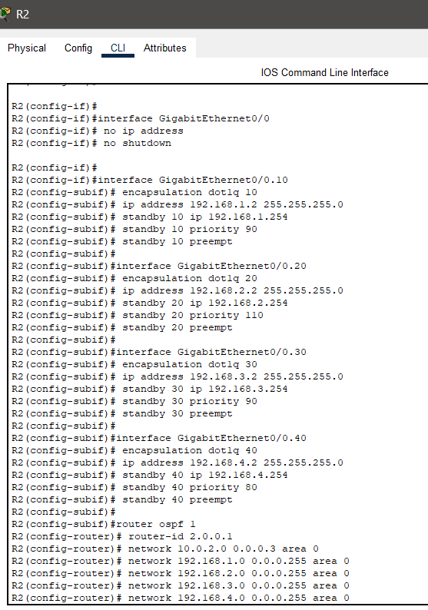

Figure 4: Subinterface setup on Router R2

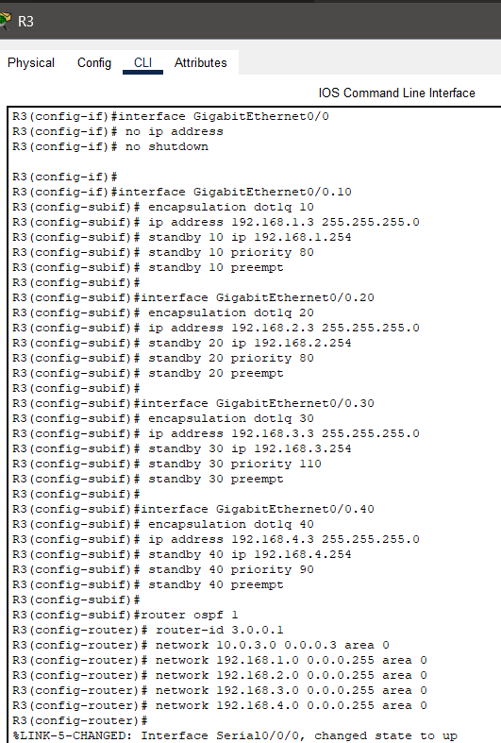

Figure 5: Subinterface setup on Router R3

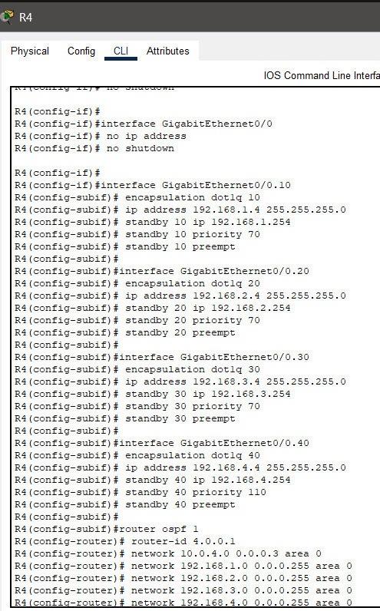

Figure 6: Subinterface setup on Router R4

HSRP Configuration

| **VLAN** | **Virtual IP** | **Primary Router** | **Priority** |
| --- | --- | --- | --- |
| 10 | 192.168.1.254 | R1 | 110 |
| 20 | 192.168.2.254 | R2 | 110 |
| 30 | 192.168.3.254 | R3 | 110 |
| 40 | 192.168.4.254 | R4 | 110 |



Figure 7: HSRP configuration on Router R1 for VLAN 10.

Virtual IP is 192.168.1.254 with priority 110. R1 is set as the active router.



Figure 8: HSRP configuration on Router R2 for VLAN 20.

Virtual IP is 192.168.2.254 with priority 110. R2 acts as the active gateway.



Figure 9: HSRP configuration on Router R3 for VLAN 30.

Shows virtual IP 192.168.3.254 and priority 110 for active role.



Figure 10: HSRP configuration on Router R4 for VLAN 40.

R4 is configured with virtual IP 192.168.4.254 as the active router.

End Devices

| **PC** | **IP Address** | **Default Gateway** | **VLAN** | **Switch** |
| --- | --- | --- | --- | --- |
| PC1–PC3 | 192.168.1.11–13 | 192.168.1.254 | 10 | S1 |
| PC4–PC6 | 192.168.2.11–13 | 192.168.2.254 | 20 | S2 |
| PC7–PC9 | 192.168.3.11–13 | 192.168.3.254 | 30 | S3 |
| PC10–PC12 | 192.168.4.11–13 | 192.168.4.254 | 40 | S4 |

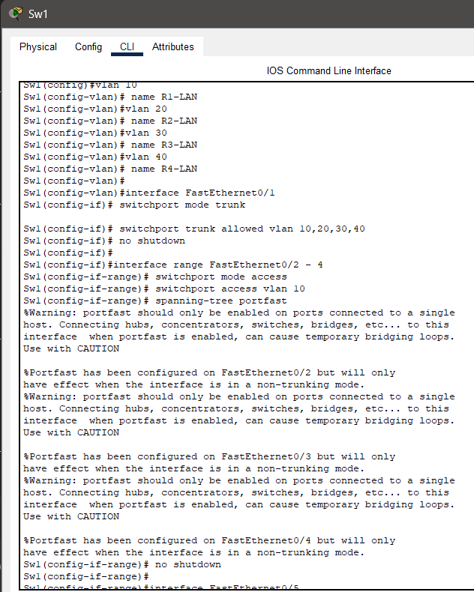

Figure 11: IP configuration of PC1 in(sw1) VLAN 10. The IP address is 192.168.1.11 with default gateway 192.168.1.254.

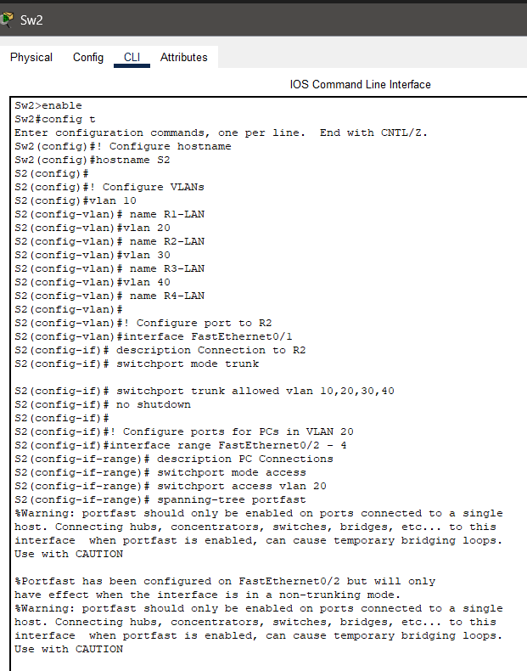

Figure 12: IP configuration of PC4 in(SW2) VLAN 20. The IP address is 192.168.2.11 with default gateway 192.168.2.254.

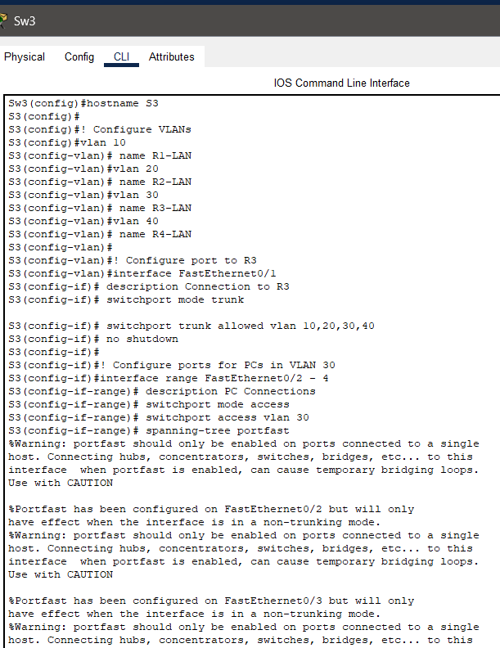

Figure 13: IP configuration of a PC connected to SW3 (VLAN 30).

The IP address is in the 192.168.3.0/24 network with default gateway 192.168.3.254.

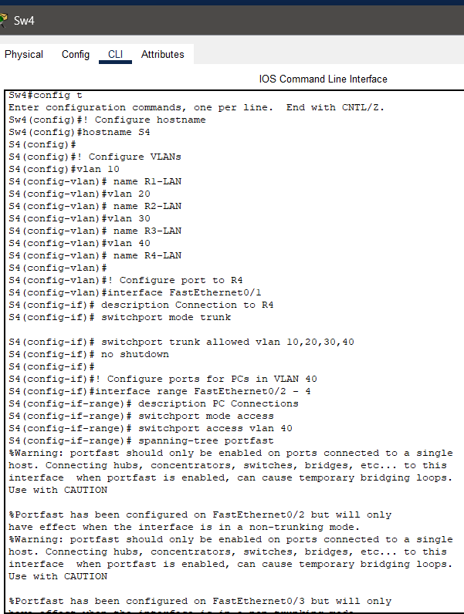

Figure 14: IP configuration of a PC connected to SW4 (VLAN 40).

The IP address is in the 192.168.4.0/24 network with default gateway 192.168.4.254.

Server

| **IP Address** | **Subnet Mask** | **Default Gateway** | **Connected To** |
| --- | --- | --- | --- |
| 172.16.0.10 | 255.255.255.0 | 172.16.0.1 | Main Router G0/0 |

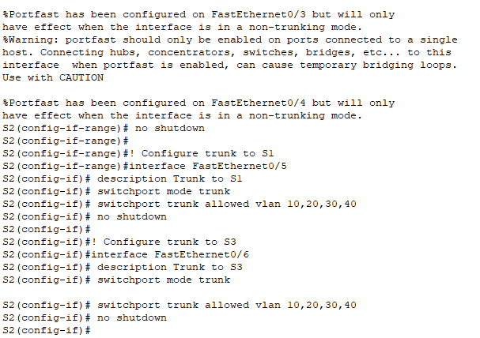

Figure 15: Server configuration showing static IP 172.16.0.10, subnet mask 255.255.255.0, and default gateway 172.16.0.1.

The server is connected to the Main Router's G0/0 interface.

OSPF Configuration

| **Router** | **Router ID** |
| --- | --- |
| Main Router | 1.1.1.1 |
| R1 | 1.0.0.1 |
| R2 | 2.0.0.1 |
| R3 | 3.0.0.1 |
| R4 | 4.0.0.1 |

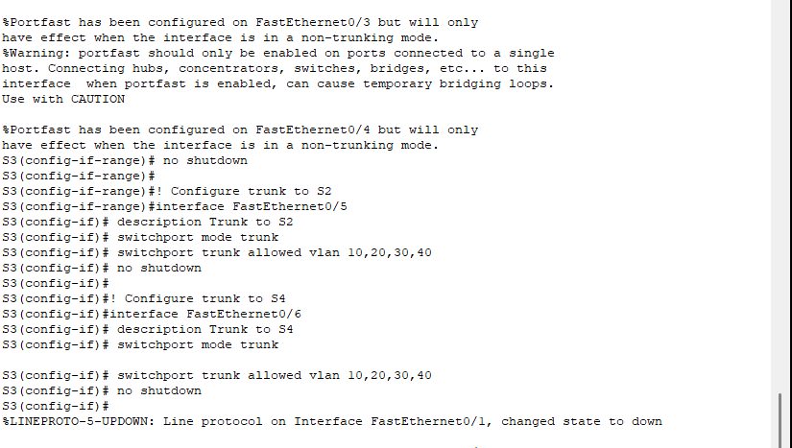

Figure 16: OSPF configuration on Router R1 showing router ID 1.0.0.1 and advertised networks.

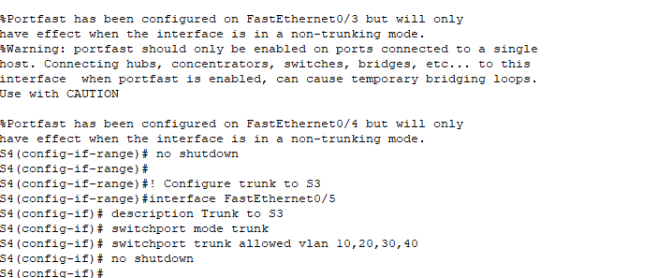

Figure 17: OSPF setup on Router R3 with router ID 3.0.0.1 and network statements for area 0.

This network was designed to ensure redundancy, logical segmentation, and dynamic routing using HSRP and OSPF. All devices are configured and tested successfully.